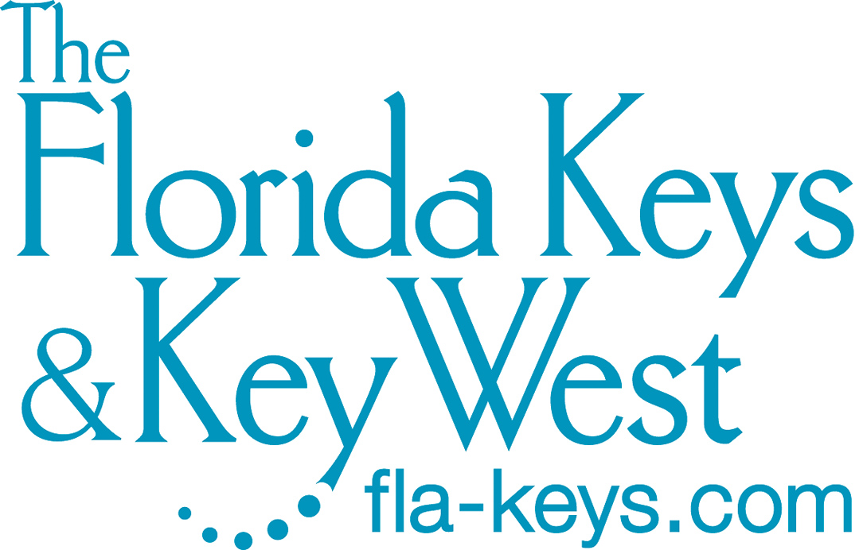
media@fla-keys.com
fla-keys.com/media
1-800-ASK-KEYS
305-461-3300
Contact: NewmanPR
Andy Newman/Carol Shaughnessy

Key West — Southernmost City in the Continental United States

Mile Markers 4 to 0

KEY WEST, Florida Keys — Located closer to Cuba than to Miami, Key West is Florida’s independent and irreverent southernmost subtropical paradise. A unique confluence of rich history, natural beauty, cultural diversity, historic architecture and romantic appeal makes the island a destination far removed from the rest of the continental United States.

Key West’s balmy climate, historic structures and easygoing lifestyle have long provided a refuge for writers, artists and free spirits seeking a place to soothe and satisfy a quest for independence in mind, body and soul.

Ernest Hemingway, Tennessee Williams, Elizabeth Bishop, Robert Frost, Judy Blume and Jimmy Buffett are just a few of the famous creatives who discovered solace and inspiration in the island city. So too did Bahamian shipwreck salvagers, commercial fishermen, sponge harvesters and Cuban cigar makers.

Key West has the largest historic district of wood-frame buildings in the nation. And history lovers can discover the island’s Bahamian and Cuban heritage, prevalent around the island in restaurants, cigar shops and museums.

For intimate lodging the island provides a bounty of bed and breakfasts with architectural qualities evoking eras past, while a wide variety of resorts offers contemporary services and amenities amid scenic surroundings.

Visitors to the island actively participate in sightseeing, on-the-water excursions and eco-tours, shopping, exploring and dining, and then become part of the famed sunset celebration held each evening at Mallory Square. The waterfront venue features tightrope walkers, jugglers, musicians, acrobats and even animal acts that strive to top a more captivating performer: the fiery sun setting into the Gulf of Mexico.

In Key West, visitors can “flamingle” with two flamingos, explore a curiously comforting cemetery, tour Hemingway’s former home and other attractions, discover the riches of a spectacular salvage expedition and enjoy exceptional cuisine. Island beaches offer ample sunning and watersports, while beneath the surrounding turquoise and cobalt waters, historic shipwrecks, a living coral reef and myriad marine plants and animals entice divers and snorkelers eager to explore.

For anglers, billfish beyond the reef and permit and tarpon on the flats are just a few of the local game fish that offer challenging displays of strength.

At night, stars illuminate entertainment opportunities including jazz clubs, piano bars, drag shows and saloons. In addition, theatrical stagings at area playhouses present quality performances and concerts feature talents from local to national.

While the Florida Keys are known as “the islands you can drive to,” Key West is easily accessible by plane via Key West International Airport, with nonstop flights from numerous U.S. metropolitan regions as well as the Florida cities of Fort Lauderdale, Miami, Orlando and Tampa. For airline and flight information visit eyw.com.

Visitors can also reach Key West by flying into Miami or Fort Lauderdale–Hollywood international airports and driving from the Florida mainland down the Florida Keys Overseas Highway (U.S. Highway 1) — designated an All-American Road under the National Scenic Byways program.

For visitors traveling from Southwest Florida, the Key West Express offers a comfortable year-round ferry journey from Fort Myers Beach and seasonal service from Marco Island. Key West’s downtown ferry terminal is within walking distance of the island’s major attractions. Visit keywestexpress.net.

WHAT TO EXPERIENCE IN KEY WEST

Audubon House & Tropical Gardens, 205 Whitehead St.; 305-294-2116, audubonhouse.org. An Audubon Experience room of brightly colored artwork pays homage to artist and ornithologist John James Audubon, who visited Key West in 1832. The restored historic home contains original Audubon engravings commemorating his Key West visit when he sketched 22 new species for his famed “Birds of America” folio.

Bahama Village, Petronia Street. This revitalized 16-block neighborhood showcases Key West’s Caribbean heritage through Bahamian markets, boutiques and restaurants. It lies southwest of Whitehead Street and northeast of Truman Annex.

Conch Tour Train, 303 Front St.; 888-916-8687 or 305-707-5775, conchtourtrain.com; and Old Town Trolley Tours, Mallory Square; 855-623-8289, trolleytours.com/key-west/. Both tour operations offer guided and informative expeditions throughout Key West, departing every half-hour. Private tours are offered in English, German, French, Italian, Mandarin, Portuguese and Spanish.

Curry Mansion, 511 Caroline St.; 305-294-5349, currymansion.com. An elaborate Victorian mansion built in 1869 on the site of the homestead of Florida’s first millionaire, Curry Mansion is now a bed and breakfast with antique-filled public areas open for tours. Listed on the National Register of Historic Places, the property showcases an era of bygone elegance. Historians believe Key lime pie was originally created in the Curry Mansion kitchen.

Duval Loop, 305-809-3911, cityofkeywest-fl.gov/326/Duval-Loop. Colorful pink and blue buses, a complimentary city-operated hop-on, hop-off bus service, travel around the island’s Historic Seaport and downtown Duval Street tourist districts. The route allows riders to get on and off near Key West’s top visitor attractions, hotels, museums, boutiques and eateries.

Ernest Hemingway Home & Museum, 907 Whitehead St.; 305-294-1136, hemingwayhome.com. The late author’s home and second-story writing studio offer a glimpse into American literary history. While living here during the 1930s, Hemingway wrote some of his most notable works including “To Have and Have Not,” set in Depression-era Key West. The island city’s most popular attraction, it’s home to dozens of cats, some six-toed that are believed to be descended from a feline given to Hemingway.

Fort East Martello Museum, 3501 S. Roosevelt Blvd.; 305-296-3913, kwahs.org/museums/fort-east-martello/visit. Construction of this historic military fort began in 1862 to provide protection for Key West against a potential sea assault by enemy forces. Today the fort, near Key West International Airport, is filled with unique artifacts and memorabilia, including Robert the Haunted Doll, and the works of the late local artist Stanley Papio.

Fort Jefferson, Dry Tortugas National Park, 305-242-7700, nps.gov/drto/historyculture/fort-jefferson.htm. This Civil War–era fort, once a Union military prison, is the Western Hemisphere’s largest masonry structure. Its most famous prisoner was Dr. Samuel Mudd, incarcerated for providing medical assistance to President Abraham Lincoln’s assassin. Fort Jefferson is the centerpiece of pristine Dry Tortugas National Park, approximately 70 miles west of Key West in the Gulf of Mexico and accessible to visitors by ferry and seaplane.

Fort Zachary Taylor Historic State Park, 601 Howard England Way (accessed through Truman Annex); 305-292-6713, floridastateparks.org/parks-and-trails/fort-zachary-taylor-historic-state-park. Fort Zachary Taylor remained under Union control throughout the Civil War and was later used during the Spanish-American War. The fort’s collection of Civil War–era seacoast cannons is the largest in America. The state park, the southernmost in the continental United States, features a popular beach, picnic tables, snorkeling and fishing.

Gay Key West Visitor Center, 808 Duval St.; 305-294-4603, gaykeywestfl.com. The center is located in the lively “Pink Triangle” district, known for its colorful cluster of LGBTQ nightclubs and shops around the 700 and 800 blocks of Duval Street. It’s operated by the Key West Business Guild, launched in 1978 and acclaimed as one of America’s oldest gay business associations.

Harry S. Truman Little White House, 111 Front St.; 305-671-9199, trumanlittlewhitehouse.org/. The late U.S. president’s former subtropical retreat, now Florida’s only presidential museum, includes family quarters, a poker porch and living and dining rooms open to the public. As well as being Truman’s working White House during his 11 trips to Key West, the house has also hosted former presidents William Howard Taft, Dwight Eisenhower, John Kennedy, Jimmy Carter and Bill Clinton.

Key West African Cemetery at Higgs Beach, Atlantic Boulevard near White Street; africanburialgroundathiggsbeach.org. Believed by experts to be the United States’ only African refugee cemetery, the oceanfront site was virtually forgotten until historical research and a 2002 ground-penetrating radar survey revealed the presence of graves. Historians believe the graves hold some of a group of Africans brought to Key West for sanctuary in 1860 after the U.S. Navy freed them from three American-owned slave ships captured near Cuba. An African-inspired memorial marks the site.

Key West AIDS Memorial, Atlantic Boulevard and White Street; keywestaidsmemorial.org. Completed in 1997, the Key West AIDS Memorial overlooks the Atlantic Ocean at the foot of the Edward B. Knight Pier and offers a tranquil setting for reflection and remembrance. Thought to be the world’s only official municipal monument of its kind, it is inscribed with the names of over 1,200 men and women who died of complications due to AIDS.

Key West Aquarium, 1 Whitehead St.; 305-296-2051, keywestaquarium.com. Opened in 1935 as Key West's first attraction, today the Key West Aquarium showcases the diverse marine life that inhabits the Florida Keys including sharks, grouper, moray eels, stingrays and tropical fish. The aquarium features a touch tank along with tours and conservation talks throughout the day.

Key West Butterfly & Nature Conservatory, 1316 Duval St.; 305-296-2988, keywestbutterfly.com. The conservatory, believed to be the only one in the country with pink flamingos, features a 5,000-square-foot glass-domed tropical butterfly habitat. Visitors can observe hundreds of butterflies, representing 50 to 60 species, and exotic birds from 20 species. Flamingo fans can “flamingle” with Rhett and Scarlett, a male and female breeding pair, during prebooked daily hourlong encounters.

Key West Cemetery, 701 Passover Lane; 305-809-3986, cityofkeywest-fl.gov/Facilities/Facility/Details/Key-West-Cemetery-21. At the 19-acre cemetery, established in 1847 and rich with the island’s history, there are headstones that read, "I Told You I Was Sick" and “Devoted Fan of Singer Julio Iglesias.” A historic plot pays homage to sailors killed in the explosion of the U.S.S. Maine. The cemetery is the final resting place for between 80,000 and 100,000 people, including Ernest Hemingway’s fishing captain friend “Sloppy Joe” Russell and sparring partner Kermit “Shine” Forbes.

Key West Firehouse Museum, 1024 Grinnell St.; 305-849-0678, keywestfirehousemuseum.com. Housed in Fire Station No. 3, one of the oldest fire stations in Florida, the museum contains artifacts from the island’s firefighting history. Notable items include a 1929 American La France fire engine, a 1906 bell, historic photos, an early alarm system and one of the only remaining indoor coal pits in America.

Key West Garden Club at West Martello Tower, 1100 Atlantic Blvd.; 305-294-3210, keywestgardenclub.com. The never-used Civil War-era fort overlooking the Atlantic Ocean is now home to the Key West Garden Club and one of Key West’s most tranquil spots. The fort’s brick pathways and grounds shelter butterfly, waterfall, prehistoric, native, orchid, perfume and cactus gardens. It’s open daily to explore; guided tours can be prescheduled.

Key West Golf Club, 6450 E. College Road; 305-294-5232, keywestgolf.com. The Rees Jones–designed championship course is the Florida Keys’ only public 18-hole course. It features a clubhouse, pro shop and instructional programs.

Key West Historic Seaport, 201 William St. on the waterfront from Front to Grinnell streets; keywesthistoricseaport.com. Some 100 land- and sea-based waterfront businesses bring Key West’s seafaring heritage to life. Along a half-mile harbor walk are shops, restaurants, bars and a working marina that’s home to tall ships, sailboats, catamarans and eco-tour vessels that provide dive, snorkel and sunset cruises.

Key West Lighthouse & Keeper’s Quarters, 938 Whitehead St.; 305-294-0012, kwahs.org/museums/lighthouse-keepers-quarters/visit. Erected in 1848, the lighthouse guided mariners until it was decommissioned in 1969. Both the keeper’s quarters and the lighthouse are restored and operated by the Key West Art & Historical Society. Visitors can climb 88 steps to the top for a sweeping scenic view of the island. Small groups can book the exclusive 90-minute Key West Lighthouse Sunset Experience.

Key West Museum of Art & History at the Custom House, 281 Front St. near Mallory Square; 305-295-6616, kwahs.org/museums/custom-house/visit. Operated by the Key West Art & Historical Society, the red-brick Custom House dates back to 1891 and is a stunning example of Richardsonian Romanesque architecture A vital repository for Florida Keys historical and cultural artifacts, the museum has curated and hosted exhibitions dedicated to Ernest Hemingway, the Florida Keys Over-Sea Railroad, the U.S.S. Maine, the art of Mario Sanchez and the 200th anniversary of Key West’s first permanent settlement.

Key West Shipwreck Treasure Museum, 1 Whitehead St., 305-292-8990; keywestshipwreck.com. Visitors can enter the world of Key West in the mid-1800s, the era of the wreckers, or shipwreck salvagers, and learn about Key West’s unique maritime heritage and how it became the richest city per capita in the United States. Climb a 65-foot-tall lookout tower for one of the island’s best views.

Key West Tropical Forest & Botanical Garden, 5210 College Road; 305-296-1504, keywest.garden. Visitors can stroll the continental United States’ only frost-free natural conservation habitat and subtropical botanical garden. The garden features more than 6,000 rare and endangered plants and trees and provides habitat for 39 butterfly species and 202 native and migratory bird species. With 12 self-guided nature trails and boardwalks, the large pet- and child-friendly garden and educational center features flora and palms native to South Florida, Cuba and the Caribbean.

Mallory Square/Sunset Celebration, 400 Wall St. at Mallory Pier; mallorysquare.com, sunsetcelebration.org. This popular plaza faces Key West Harbor and the Gulf of Mexico. Each evening, visitors flock to see the island’s internationally renowned sunset celebration featuring street performers, arts and crafts vendors and food carts.

Mel Fisher Maritime Museum, 200 Greene St.; 305-294-2633, melfisher.org. The museum showcases the richest single collection of 17th-century maritime and shipwreck antiquities in the Western Hemisphere, including the treasure of the Spanish galleon Nuestra Señora de Atocha. Behind-the-scenes tours of the artifact conservation lab also are offered.

Oldest House Museum & Gardens, 322 Duval St.; 305-294-9501, oldesthousekeywest.com. Believed to be the oldest home in Key West, this 1829 structure features portraits, artifacts, antiques, ship models and documents recalling Key West’s rich heritage. Operated by the Old Island Restoration Foundation, the property also includes tropical gardens containing the oldest surviving cook house in South Florida.

Sails to Rails Museum, Flagler Station, 901 Caroline St.; 305-295-3562. trolleytours.com/key-west/sails-to-rails-museum. The museum features an interactive timeline of Key West history and highlights of its “age of sail” heyday and the sponge and turtle harvesting, shipwreck salvaging and cigar making industries. Visitors also can learn about Henry Flagler, the visionary who conceived and built the Florida Keys Over-Sea Railroad.

San Carlos Institute, 516 Duval St.; 305-294-3887, institutosancarlos.org. Founded in 1871 by Cuban exiles, the San Carlos functioned as an educational, civic and patriotic community center. In a historic 1892 speech from the building, Cuban patriot Jose Marti united Key West’s Cuban exile community, launching his drive for Cuba’s independence. Today the San Carlos features exhibits about the history of Cuba and Florida’s Cuban-American population.

Southernmost House, 1400 Duval St.; 305-296-3141, southernmosthouse.com. Built in 1896 overlooking the Atlantic Ocean, the pastel-hued house, with Queen Anne–style architecture and elegant gables, epitomizes the grandeur of the island city’s historic heyday. The frequently photographed landmark now is a popular beachfront boutique hotel.

Southernmost Point, Whitehead and South streets. This larger-than-life buoy marks the southernmost spot in the continental United States — only 90 miles from Cuba. It’s a photo-op stop for nearly every visitor to Key West.

Smathers Beach, South Roosevelt Boulevard; cityofkeywest-fl.gov/Facilities/Facility/Details/Smathers-Beach-5. The largest of the beaches operated by the city of Key West, this popular Atlantic Ocean expanse offers watersports rentals and volleyball courts. A popular site for oceanside weddings, it’s open from sunrise to sunset.

Tennessee Williams Museum, 513 Truman Ave.; 305-204-4527, kwahs.org/museums/tennessee-williams/visit. Internationally renowned playwright Tennessee Williams lived in a Key West cottage at 1431 Duncan St. for 34 years. Williams’ Key West years and legacy are chronicled in this tiny museum that includes personal photographs, memorabilia, first edition plays and books.

Truman Waterfront Park, end of Southard Street; cityofkeywest-fl.gov/Facilities/Facility/Details/Truman-Waterfront-Park-52. Key West’s popular 28-acre Truman Waterfront Park offers attractions including a children’s play area and splash park, picnic areas, bike lanes, landscaped green space, exercise stations and an amphitheater. Surrounded by grassy tiers, the park’s state-of-the-art Coffee Butler Amphitheater has become a favored venue for high-visibility concerts, special events and festivals.

U.S. Coast Guard Cutter Ingham Maritime Museum, Truman Waterfront at the end of Southard Street; 305-292-5072, uscgcingham.org. The 327-foot Ingham, launched in 1936, is one of only two preserved Secretary-class cutters and the only cutter ever awarded two Presidential Unit citations. The vessel was in service for 52 years and in 1986 became the most decorated military ship in the fleet. Visitors can tour most areas of the ship and view period artifacts, navigational equipment and photographs.

Key West visitor information: fla-keys.com/keywest or 1-800-LAST-KEY

Florida Keys visitor information: fla-keys.com or 1-800-FLA-KEYS
Social: Facebook • Twitter • Instagram • YouTube • Pinterest • TikTok • Keys Voices Blog

###

0125

